How To Write a Problem Statement for Your Business Idea
What is Problem Statement & Opportunity?
A problem statement is a short and succinct definition of the problem you plan to solve and why it’s important. Creating a clear problem (and opportunities) statement is an essential element for any project, as it highlights the challenges faced by customers and the business potential for solving them.
This guide will walk you through the process of crafting a clear, concise, and compelling statement that resonates with both customers and stakeholders. By following these five simple steps, you’ll be on your way to developing a successful project with a strong foundation.

Before You Start
Before you write your problem statement you should have a clear vision of what you want to achieve with your intrapreneurial venture, and a clear picture of who you are solving the problem for (in other words – your ideal customer).
Then, when you have your customer persona and vision statement clear, move on to define your problem statement.
You need to be able to articulate the problem you’re solving in very simply terms.
Why?

Because it’s the first thing you’ll need to explain in a pitch. It’s what any new team member will immediately need to understand. And without it, everyone will end up solving different problems – which will ultimately lead to failure.

THE PROBLEM STATEMENT CANVAS INCLUDES THE FOLLOWING STEPS:-

Step 1: Frame Your Problem Statement with Your Project Vision
Before diving into the problem and opportunities statement, it’s crucial to have a clear vision for your project. Jot a short statement of how your customer’s world will be better when your solution exists. This will ensure you have a solid understanding of the context in which the problem exists and the outcome will deliver for your customer. Importantly, it will help you stay focused on the customer’s needs and set the stage for the rest of the process.

Step 2: Write a Simple Statement of the Problem from the Customer’s Perspective
Now that you have your project vision in mind, it’s time to define the problem you’re trying to solve. Craft a one-sentence statement that succinctly describes the issue from the customer’s point of view. This statement should be simple, yet powerful enough to convey the problem’s essence and the pain it causes.
Example: “Young professionals are struggling to find reliable, affordable, and eco-friendly transportation options for their daily commute.”

Step 3: Identify What People Do Today To Solve The Problem
With the problem identified, outline the current workarounds or alternative solutions that customers are using to deal with the issue. This information will help you and your team understand the existing landscape and identify areas where your project can offer unique value.
Example: “Today, people rely on a mix of public transportation, private vehicles, and rideshare services, all of which have their drawbacks in terms of cost, reliability, or environmental impact.”
⚠ Warning: If you can’t find any existing solutions or customer-created workarounds that people are using to address the problem, consider this a red flag. It means that the problem isn’t significant enough for customers to invest time and effort in solving, which will likely result in a lack of market demand for your solution. Your best bet in this case is to move on to other problems with greater potential for success.

Step 4: Identify Why This is an Important Problem to Solve
Next, explain why solving this problem is vital for the customer. Describe the consequences if the issue remains unresolved, and highlight the benefits of addressing it. Remember, your solution should be important enough that customers will be willing to spend money on it.
Example: “If left unsolved, this problem contributes to increased pollution, higher transportation costs, and longer commutes. By addressing it, we can offer customers a more sustainable, cost-effective, and dependable transportation alternative.”

Step 5: Identify The Scale of the Business Opportunity
Finally, articulate the business opportunity for your company. Describe the potential revenue and growth that can result from solving the problem, and explain why investing time and resources in this project is worthwhile. This section should be persuasive, demonstrating the value of pursuing this opportunity.
Example: “The market for eco-friendly commuting is forecast to grow to $900 billion by 2027. By developing a solution for this transportation issue, we can tap into the growing market demand for eco-friendly commuting options. With a scalable and cost-effective solution, we can establish ourselves as a leader in this space, resulting in significant revenue generation and long-term growth.”

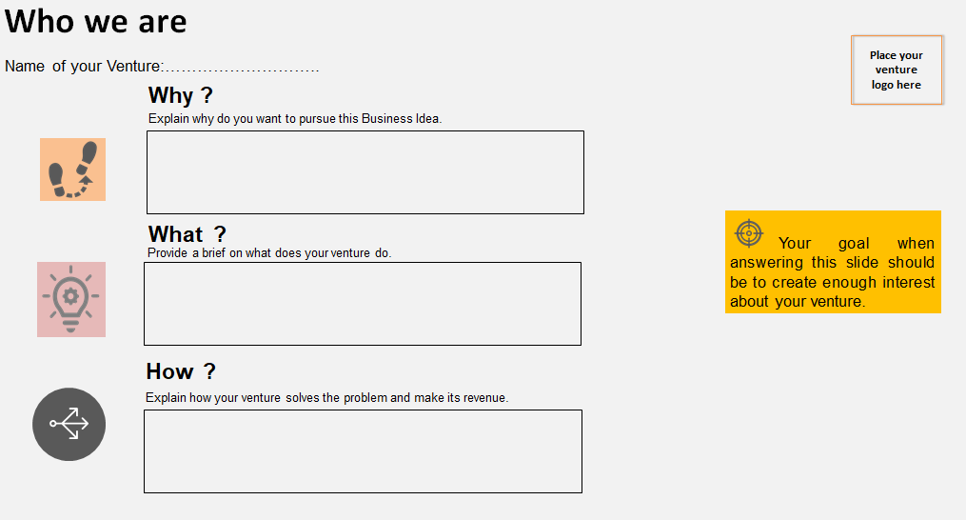

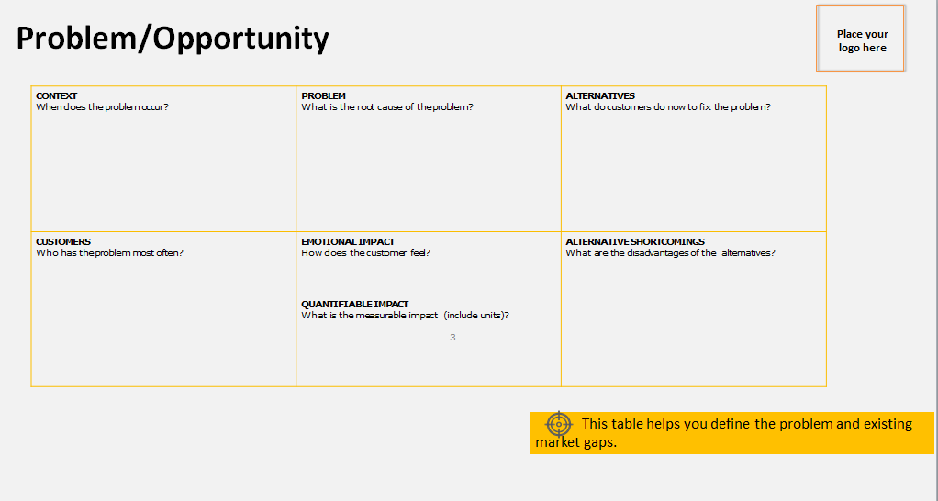

Problem Identification & Opportunity discovery:
1. ANALYZE YOUR INDUSTRY AND THE THINGS YOU DO EVERY DAY
It sounds simple, but we are constantly encountering problems, big and small, over the course of our regular day. Pittman said, “Oftentimes, these are things that bother you – inefficiencies.” These problems can be at work, within our industries, or during our leisure activities. Identifying these problems is the catalyst for a successful idea.

“We have more and more issues that are happening every day, and it provides more opportunities for entrepreneurs to dive in, identify them, see if they can solve them, and come up with a marketable approach,” Pittman said.

Pittman suggested asking yourself, “What’s a problem in your life?”

2. CONFIRM YOUR SUSPICION BY ASKING OTHERS IF THIS IS A PROBLEM FOR THEM, TOO
Confirming a suspicion that a problem is a real one is important before setting out to solve it. You may begin by asking friends and family if they experience the same problem, then eliminate any easy solutions you may have missed.

3. DETERMINE THE MAGNITUDE OF THE PAIN
Once you confirm that others relate to your problem, you’ll need to determine the magnitude of their pain. If the problem is frustrating but inconsequential, it likely cannot be monetized.

Pittman said, “If you have a problem, and your goal is to monetize the solution to your problem, you want two things: repeatability and market size.”

Repeatability: how many people agree your problem is a real one and that it happens enough that they care enough
Market size: how many people believe the problem is painful enough to pay for a solution
“At the end of the day, you’re just trying to figure out if the problem you have is ready to be solved and if the framework that you’ve put together will help you get there,” Pittman said.

4. ACCEPT THAT 9 OUT OF 10 SOLUTIONS MAY NOT BE REPEATABLE AND SCALABLE
Continue your research and be persistent. Not every solution will produce the outcome you want, and not every problem will have an easy and straightforward solution. Persistence will be critical to success.

Pittman cautioned: “You’re probably going to throw away nine different solutions for every problem that you have.”

5. DECIDE WHAT SIZE OPPORTUNITY IS LARGE ENOUGH FOR YOU PERSONALLY TO ADDRESS THE PROBLEM
Each opportunity will have a different market, different costs, different profits, and a different overall return. There are venture-funded businesses and lifestyle businesses. If your problem impacts a smaller market and requires a lot of your time to solve, you may choose to focus on a different problem.

Ask yourself, “Is it worth it to me?”

6. MAKE THE CALL AND ACT
Confirm your market assumptions and experiment with a minimum viable product (MVP) or a Kickstarter campaign. Small, fast, and cheap wins can offer momentum to grow or to find new problems and ideas. Keep in mind that solutions may not be direct or easy; otherwise, the problem would already be solved. If you make the call that this is not the problem to solve, continue to innovate and try new things.

“When you get into that gray area if you are leaning closer to not profitable than profitable, the answer is probably: it’s not going to be profitable. In my experience, things always take three times longer and cost three times as much to take to market and develop. At the end of the day, your time is the most valuable commodity you have on Earth,” Pittman said.

7. FINALLY, LOOK AHEAD TO STAY AHEAD.
Repeat this process over and over to reach success. Pittman warned that it will take a lot of discipline and energy to move an idea through this framework. Adaptability will be important as markets change, and technology may not always be the answer. Continue to look for opportunities and watch your market closely for signs of change.

Pittman said, “At the end of the day, staying at the plate is the important thing.”

